A* search

Heuristic estimated cost to goal (straight-line distance works for this).

Edges have costs still.

The heuristic (to be helpful – admissible) **must be an underestimate**.

With an A* search: only bother exploring a route if it *might* be better than the one we've got.

from A to Z:

|  |  |  |  |  |
| --- | --- | --- | --- | --- |
| Node | Est total cost  (F = G + H) | Cost so far (G) | Heuristic cost (H) | Previous node |
| ~~A~~ | ~~21~~ | ~~0~~ | ~~21~~ | ~~-~~ |
| ~~B~~ | ~~23~~ | ~~9~~ | ~~14~~ | ~~A~~ |
| ~~C~~ | ~~22~~ | ~~4~~ | ~~18~~ | ~~A~~ |
| D | 25 | 7 | 18 | A |
| E | 26 25 | ~~21~~ 20 | 5 | ~~C~~ B |
| ~~F~~ | ~~24~~ | ~~16~~ | ~~8~~ | ~~C~~ |
| Z | 25 | 25 | 0 | F |

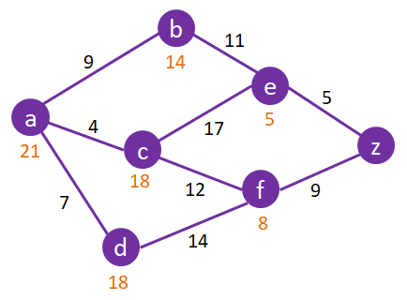

|  |  |  |  |  |
| --- | --- | --- | --- | --- |
| Node | Est total cost  (F = G + H) | Cost so far (G) | Heuristic cost (H) | Previous node |
| ~~A~~ | ~~95~~ | ~~0~~ | ~~95~~ | ~~-~~ |
| ~~B~~ | ~~130~~ | ~~50~~ | ~~80~~ | ~~A~~ |
| ~~C~~ | ~~115~~ | ~~25~~ | ~~90~~ | ~~A~~ |
| ~~D~~ | ~~150~~ | ~~75~~ | ~~75~~ | ~~B~~ |
| ~~E~~ | ~~140~~ | ~~70~~ | ~~70~~ | ~~C~~ |
| ~~F~~ | ~~140~~ | ~~75~~ | ~~65~~ | ~~C~~ |
| ~~G~~ | ~~150~~ | ~~100~~ | ~~50~~ | ~~E~~ |
| ~~H~~ | ~~155 145~~ | ~~110 100~~ | ~~45~~ | ~~E F~~ |
| ~~I~~ | ~~155~~ | ~~130~~ | ~~25~~ | ~~B~~ |
| J | ~~180~~ 160 | ~~180~~ 160 | 0 | ~~G~~ I |

